CSIS 330 – Lab 11: Troubleshooting–

OS Command Line Tools

Answer Template

**Part I: Netstat Syntax**

|  |  |
| --- | --- |
| Command | Description |
| Example:  netstat -a | Displays all connections and listening ports |
| netstat -n | Displays addresses and port numbers in numeric form |
| netstat interval | Redisplays statistics every 5 second. Press Ctrl-C to stop redisplaying statistics. |
| netstat –y | Shows connections for the TCP protocol |
| netstat –f | Displays fully qualified domain names for foreign addresses. |
| netstat -r | Displays the routing table. |

**Part II: NetStat Routing Table**

**Screenshot #1:**

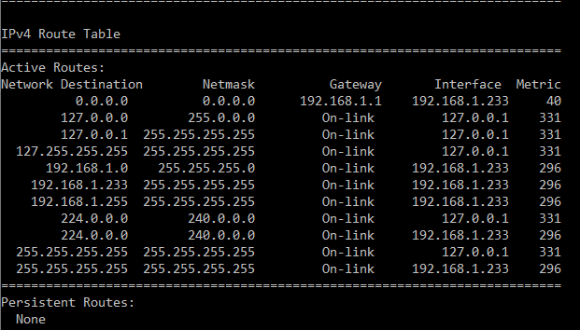

**Question #1:** What does this table show you?

**The table show the Network Destination, Netmask, Gateway, Interface, and Metric. The Network Destination in the address to which the packet is sent. The Netmask divides the IP address into subnets to specify the network’s available hosts. The Gateway is the IP address assigned to the router. The Interface is the connection between the PC and network. The Metric is the value assigned to the IP route for a given network interface.**

**Part III: NetStat Output**

**Screenshot #2:**

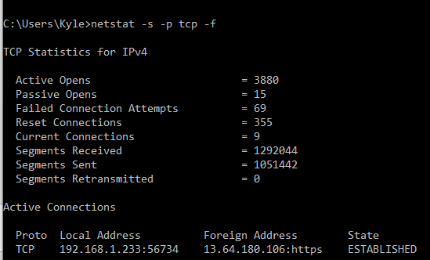

Questions:

1. How many active opens were recorded? **3880**
2. How many failed connection attempts were recorded? **69**
3. How many segments were received? **1292044**
4. How many segments were sent? **1051442**
5. How many segments were retransmitted? **0**

**Part IV: IPCONFIG**

**Screenshot #3:**

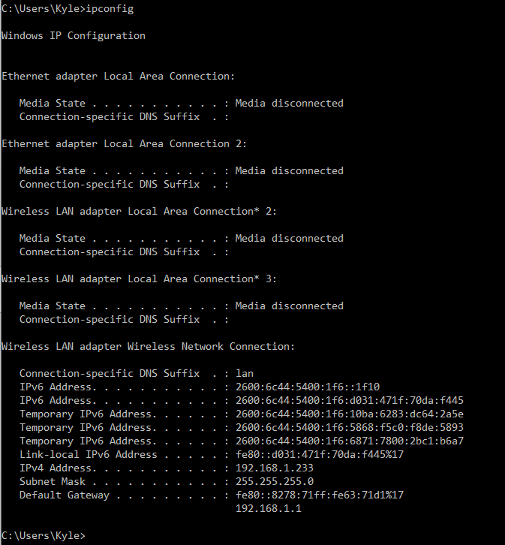

**Questions:**

1. What is your IPv4 address?

**192.168.1.233**

1. What is your subnet mask?

**255.255.255.0**

1. What is your default gateway address?

**fe80::8278:71ff:fe6371d1%17  
192.168.1.1**

**Part V: PING**

**Screenshot #4:**

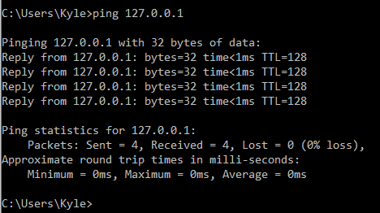

**Questions:**

1. Were you able to ping this address?

**Yes**

1. How do you know?

**4 replies were received from 127.0.0.1**

1. How many packets were sent?

**4 packets**

1. How many packets were received?

**4 packets**

1. How many packets were lost?

**0 packets**

**Part VI: TRACERT**

**Screenshot #5:**

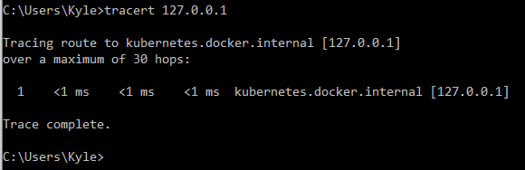

**Questions:**

1. Was the trace successful?

**Yes**

1. If the trace was successful, how many hops were performed to reach the destination?

**30 hops**